The Microsoft Power BI Interface

When you open Power BI, and close the introductory prompts, you are left with a screen that looks like the screenshot below:

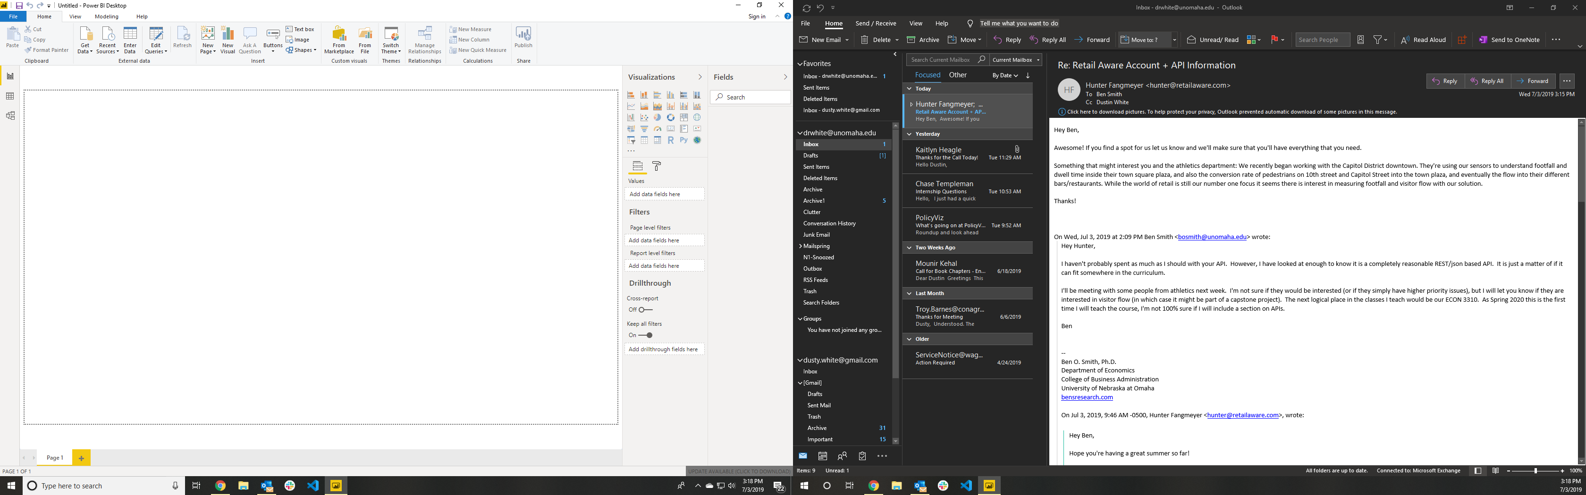

Data Fields

Control Ribbon

Visualization Tools

Canvas

The large blank space is called the “canvas.” This is where we build our visuals and other report tools. To the right of the canvas are the visualization tools column, and the column containing the data fields (information that we will eventually display). We will also use the options in the control ribbon as we import and blend data sources.

Importing Data

In order to begin the import process, we need to choose the Home ► Get Data button from the control ribbon. When we click on the icon, we will get a pop-up to choose the type of data to connect to (like the image below). If we open the dropdown menu (by clicking on the text rather than the icon), we can choose our data type directly from the dropdown.

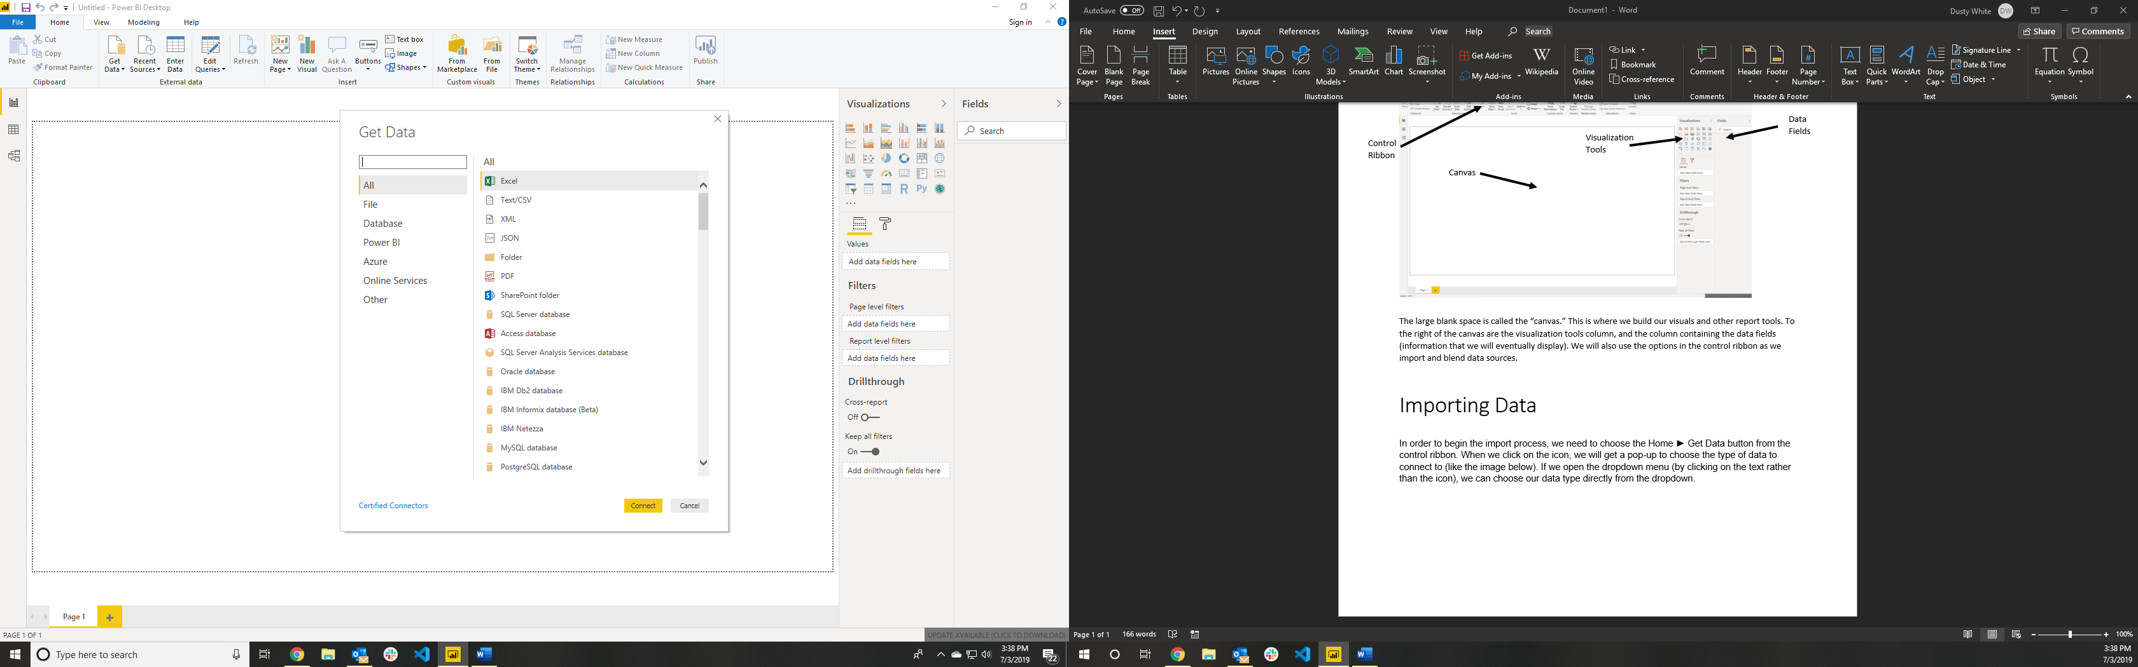

At this point, we choose the type of file (or storage) from which we will retrieve our data. Our data is stored in files with the extension “.csv”, so we will select “Text/CSV” from the list of options, then click “Connect”.

At this point, a file browser will open, and we can select the file that we wish to connect to our report. When we select a file, we are provided a preview of the data in that file. The intent of this screen is to ensure that the data we are importing looks as we expect it to. We have the option to either edit or load data. If everything looks right, we should select “Load.” If we need to make modifications, we can select “Edit.” The options available in that case will be described below.

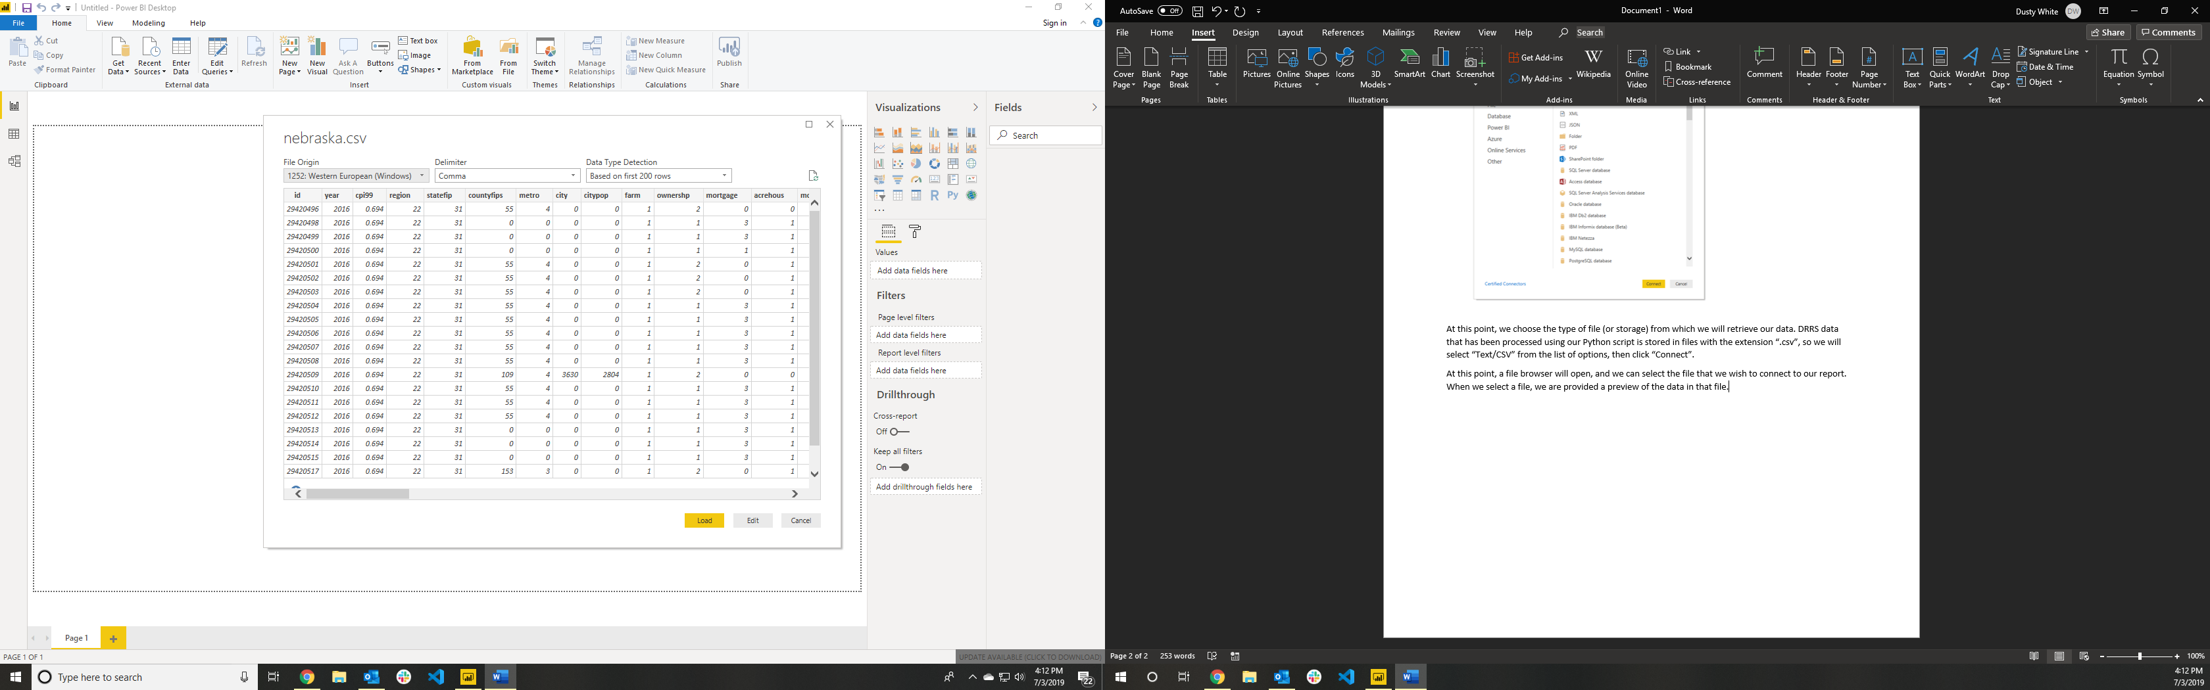

After selecting “Load,” the columns (or fields) of our data will be available to us on the main page of our report. The fields will be presented in the “Fields” column at the extreme right of the window:

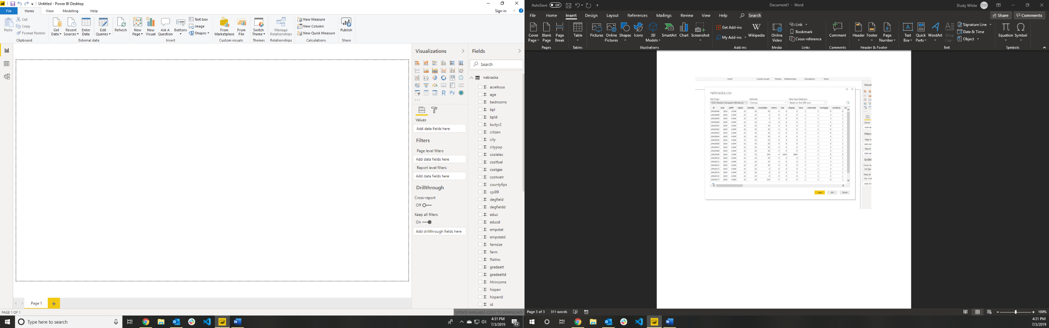

Editing the Data

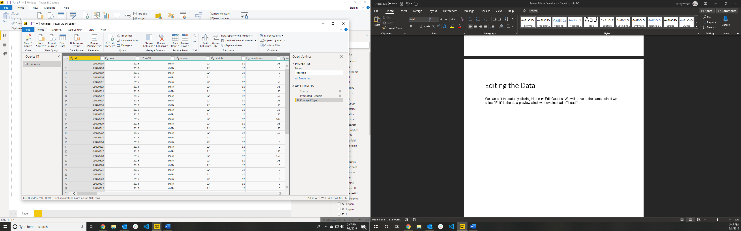We can edit the data by clicking Home ► Edit Queries. We will arrive at the same point if we select “Edit” in the data preview window above instead of “Load.” The following window will appear:

In this frame, we can change the way that Power BI treats our data. The two most useful ways to do this are to change the format of the column, and to merge queries.

Change Column Format

In order to change the format of any column, simply select the icon next to the name of the column:

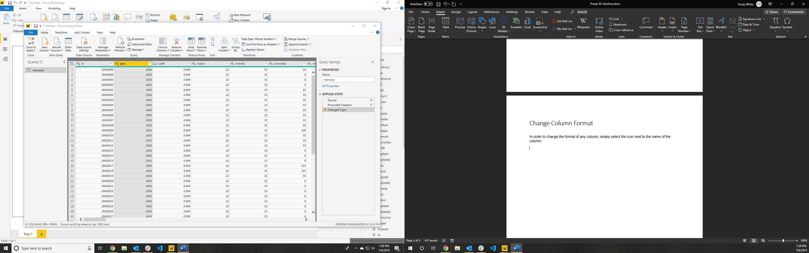

Click here

You will be provided a dropdown menu from which you can choose the appropriate column type for your data. Typically, Power BI does a good job of choosing this for you, but it may be necessary to change the format from time to time.

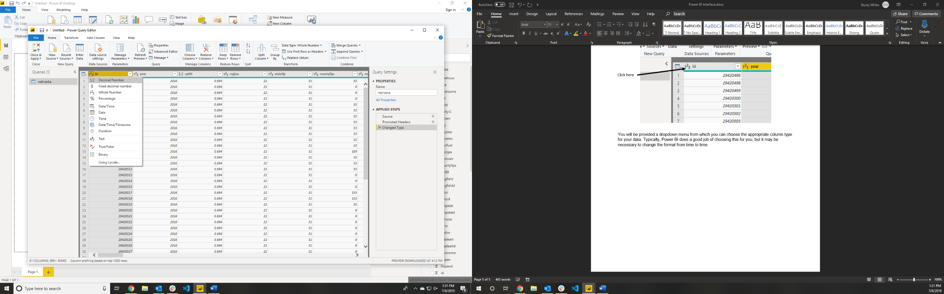

Merging Queries

Merging queries is a slightly more involved process. The goal of merging queries is to combine the information in one data source with the information available in another source. We do this by choosing the columns in each source that uniquely identify the data to combine. For example, if I want to combine information about a person with information about their state of residence, then I would choose to identify data in each source based on the state identifier present in each source.

*NOTE: The columns to match must match EXACTLY in the two data sources! If I use numbers to identify a state in one source (or a group ID), then I must use numbers in the other source, as well.*

In order to use this option, we should have at least two data sources loaded into Power BI before beginning the process of merging queries. We start the process of merging queries by clicking the Home ► Merge Queries option in the Edit Queries frame.

Click here

After clicking, a Merge prompt window will appear (as displayed below). In this window, we can select our identifying columns by clicking on them. We can hold down the Ctrl button while clicking to select more than one column to use for identification. In this case, we will start by using state and county codes to merge the text names for states and counties into our data set.

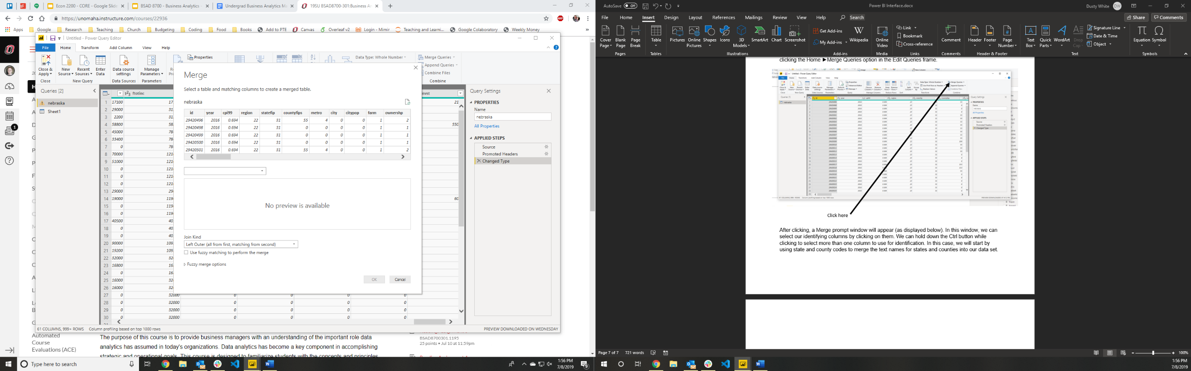

We first select the “statefip” and “countyfips” columns from the table labeled “nebraska”. Next, we select the blank dropdown menu to find the table we want to merge with “nebraska”. In this case, it is called “Sheet1”. At this point, we see a preview of the second data set, and can select the columns that correspond to our identifiers in the first data set. We should select them in the same order as they were selected above: if we select the “statefip” column first in “nebraska”, then we should also select it first in “Sheet1”.

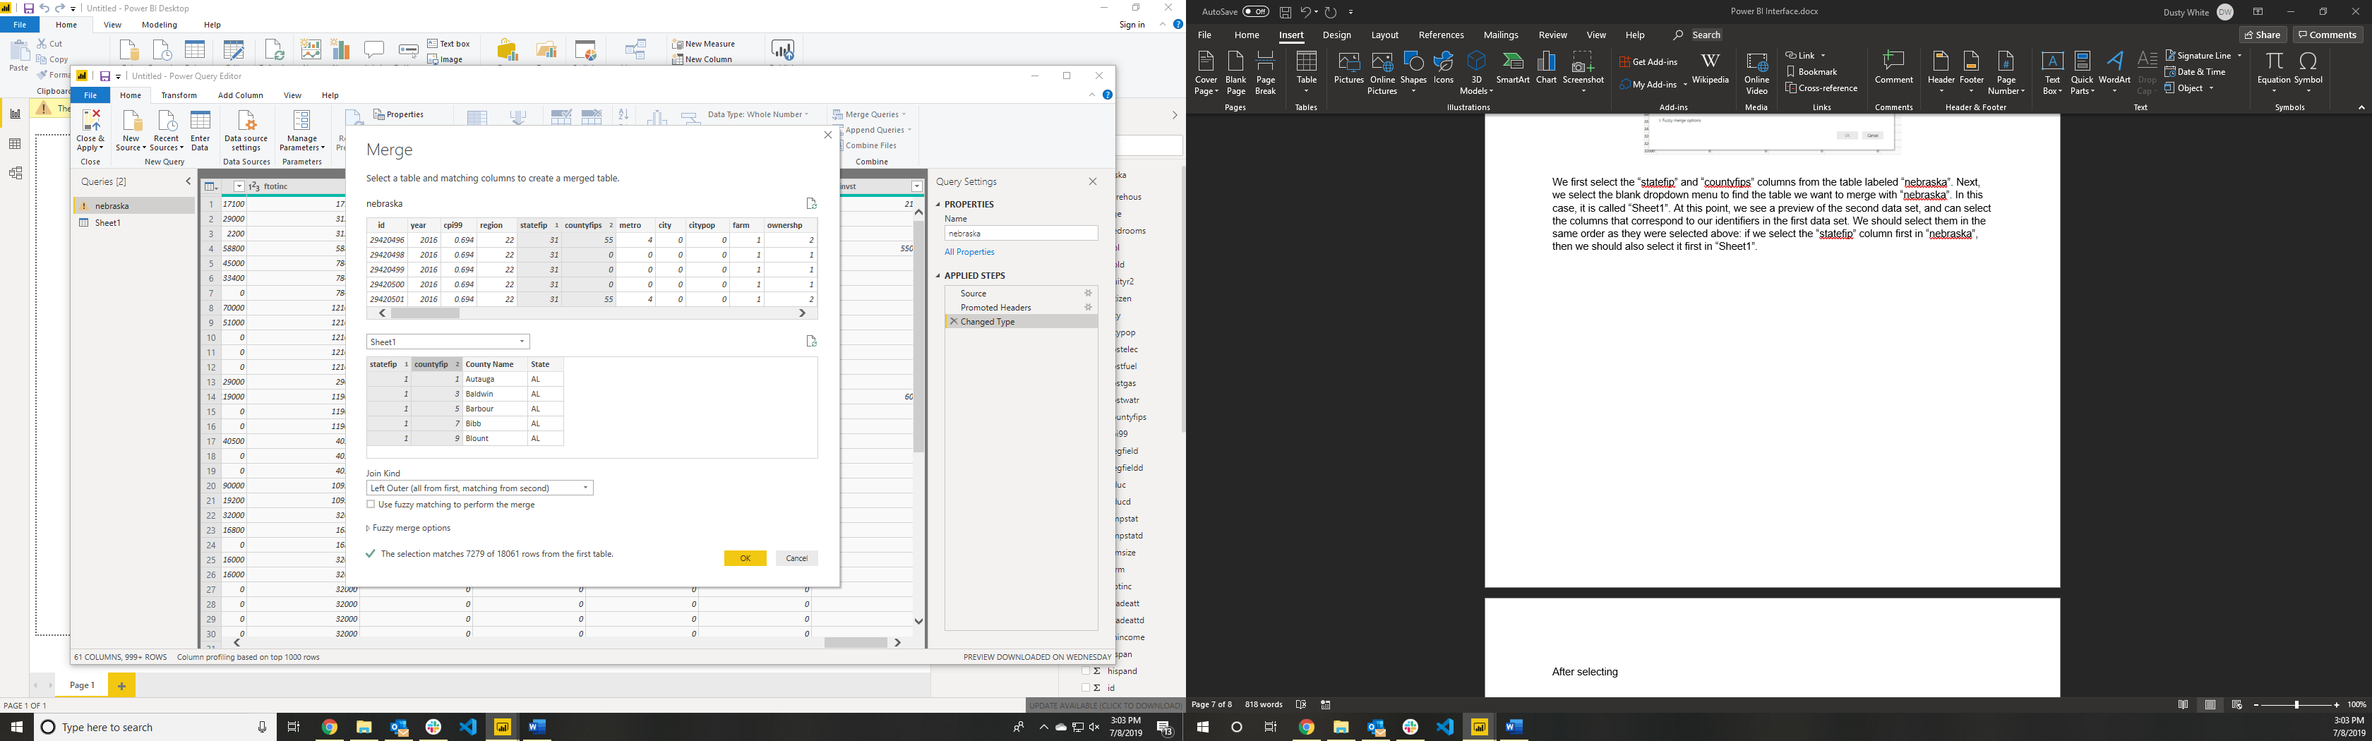

After selecting the columns, we see at the bottom of the merge window how many rows can be matched using our criteria. Typically, we would expect that all rows be matched. In the case of the Nebraska data, however, some rows have missing data and cannot be matched. Once we have matched all the rows, we can click “OK” to process our merge command.

At this point, we return to the Edit Queries window. We are shown a new column named after our second data set. In order to see the matched rows, we can click the icon in the top right corner of the column label.

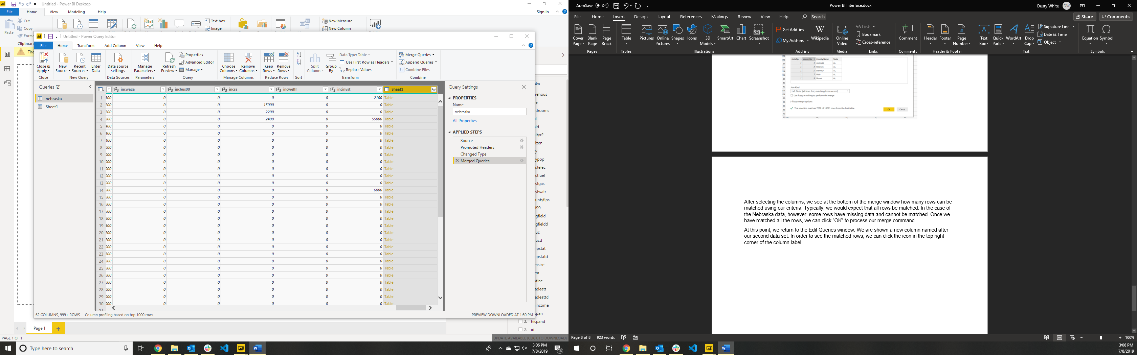

Click here

Clicking this button will provide us with a dropdown of the available matched columns. We can select the columns we wish to include in the merged data set. In our example, we will only choose the text columns of County and State names, and will not include “Sheet1” as a prefix to the column names.

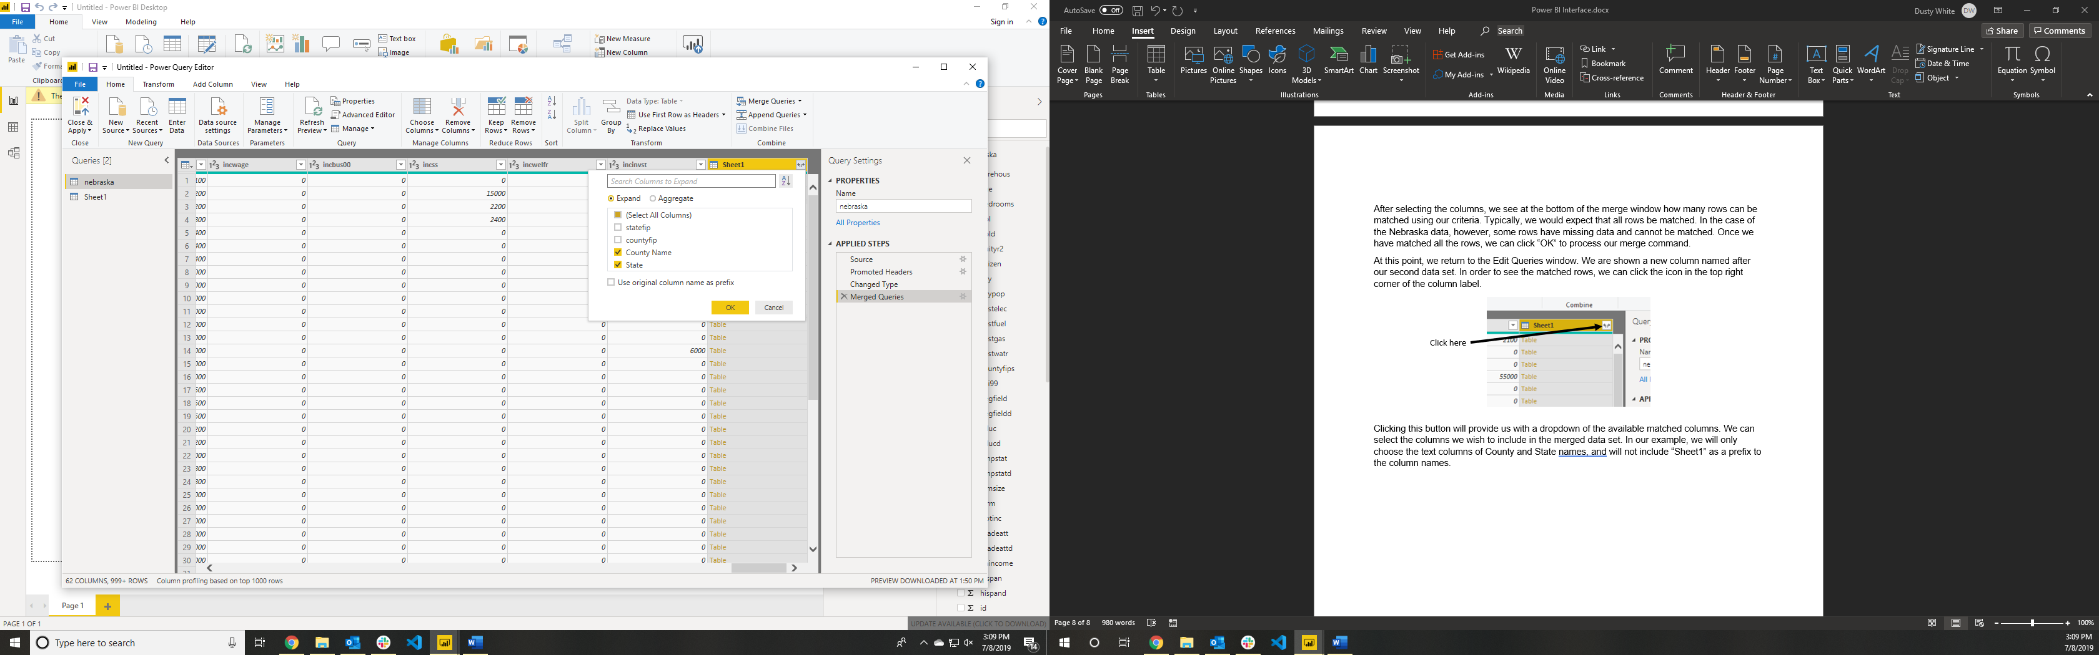

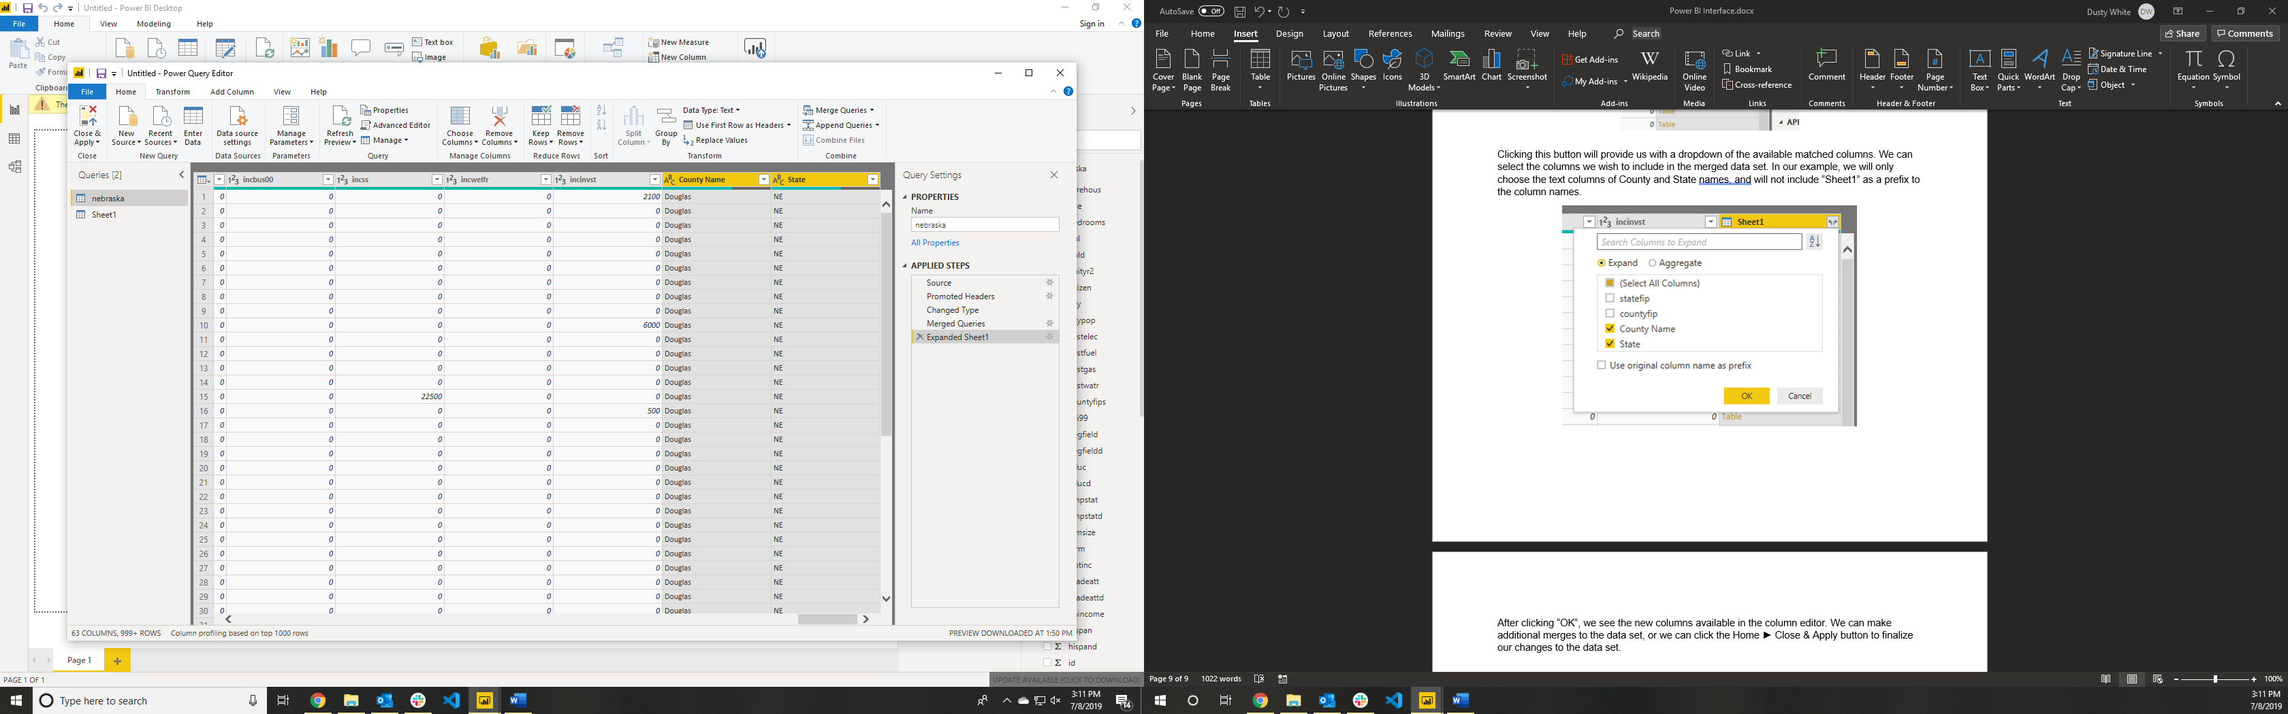After clicking “OK”, we see the new columns available in the column editor. We can make additional merges to the data set, or we can click the Home ► Close & Apply button to finalize our changes to the data set.

Click here

Generating Plots

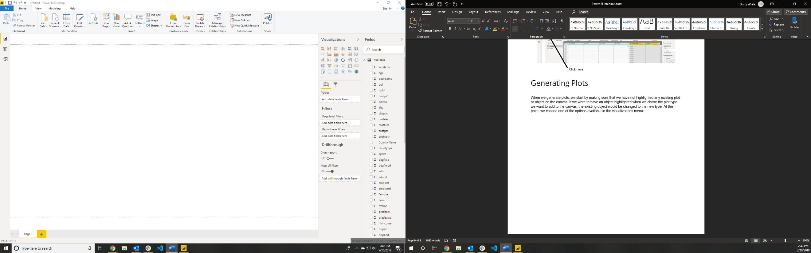When we generate plots, we start by making sure that we have not highlighted any existing plot or object on the canvas. If we were to have an object highlighted when we chose the plot type we want to add to the canvas, the existing object would be changed to the new type. At this point, we choose one of the options available in the “Visualizations” menu:

Choose one of the options available

At this point, an empty visual will appear in the canvas, and we need to provide the necessary data to complete the visual. The following sections will address the features of available visualization types.

Stacked Column Chart

A column chart is designed to provide comparisons of magnitude and (in the case of the stacked column chart) composition across categories. When we select the stacked column chart, we are required to provide at least two fields: axis and value.



Click here

The field provided in the “Axis” prompt will be the variable that describes the various groups to be measured separately. The field provided in the “Value” prompt is the value that we wish to measure:

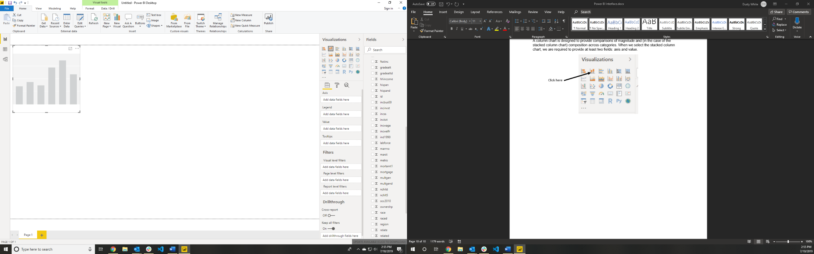

Drag the field that you wish to be the “Axis” data here

Drag the field that you wish to be the “Value” data here

As you add fields to the visual, you will see the visual update in real time. Once a field has been dropped into a visual, it can be removed by clicking the “X” button that appears next to the field name in the same area where it was dropped:

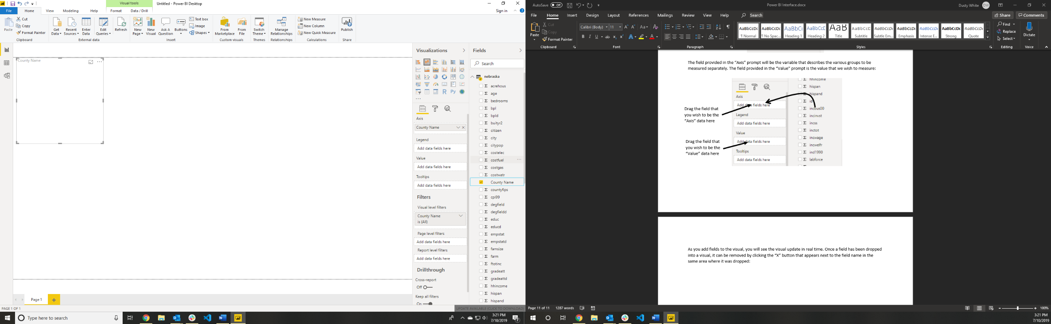

Click here to remove field from visual

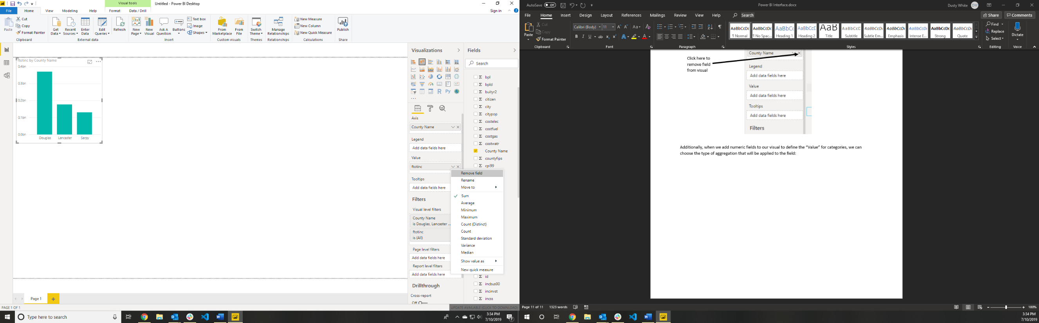Additionally, when we add numeric fields to our visual to define the “Value” for categories, we can choose the type of aggregation that will be applied to the field. This is done by clicking the down arrow next to the “X” that will remove the field from the visual:

In most cases, the “Sum” or “Average” choice are the best options. The “Sum” option should be used in the case of a stacked column chart. At this point, the chart will look something like this:

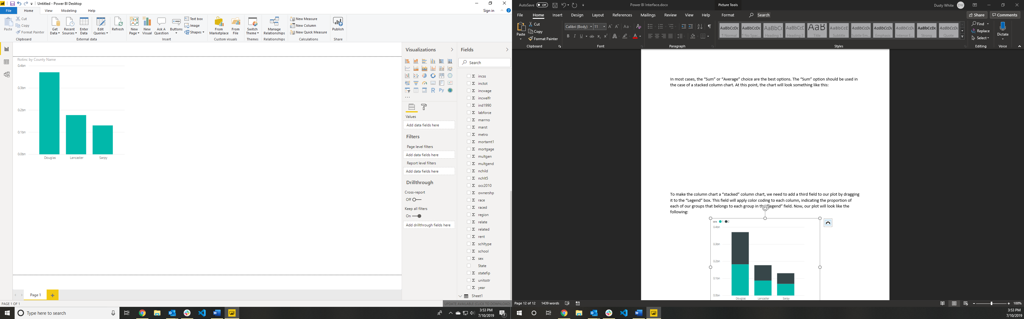

To make the column chart a “stacked” column chart, we need to add a third field to our plot by dragging it to the “Legend” box. This field will apply color coding to each column, indicating the proportion of each of our groups that belongs to each group in the “legend” field. Now our plot is ready!

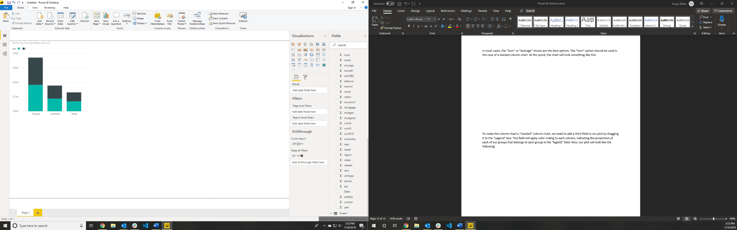

NOTE: These same procedures can be used to create row charts. A row chart simply presents the groups as horizontal rather than vertical bars.

Line Chart

A line chart is normally used to present trends over time. Much of the construction of this visual is the same as building a column or row chart.



Click here

The field provided in the “Axis” prompt will be the variable that describes the various groups to be measured separately. The field provided in the “Value” prompt is the value that we wish to measure:



Drag the field that you wish to be the “Axis” data here

Drag the field that you wish to be the “Value” data here

Additionally, when we add numeric fields to our visual to define the “Value” for categories, we can choose the type of aggregation that will be applied to the field. This is done by clicking the down arrow next to the “X” that will remove the field from the visual:

In most cases, the “Sum” or “Average” choice are the best options. At this point, the chart will look something like this:

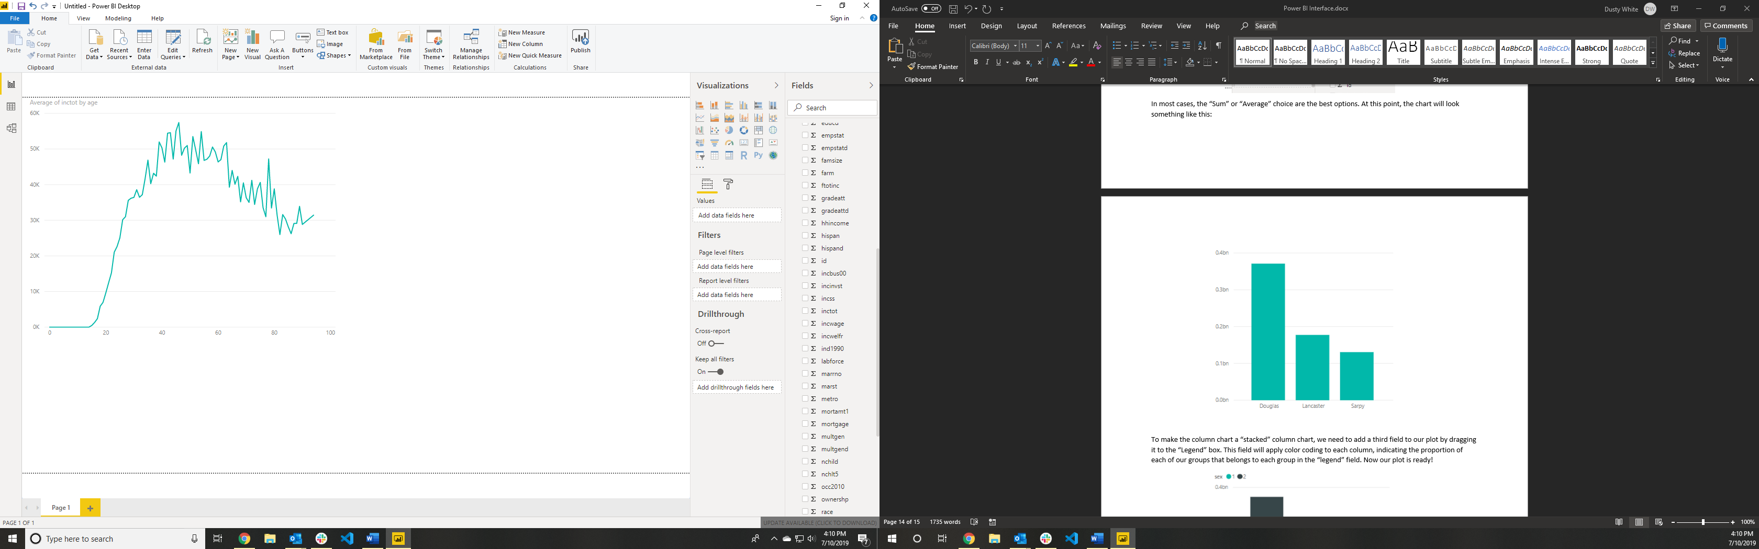

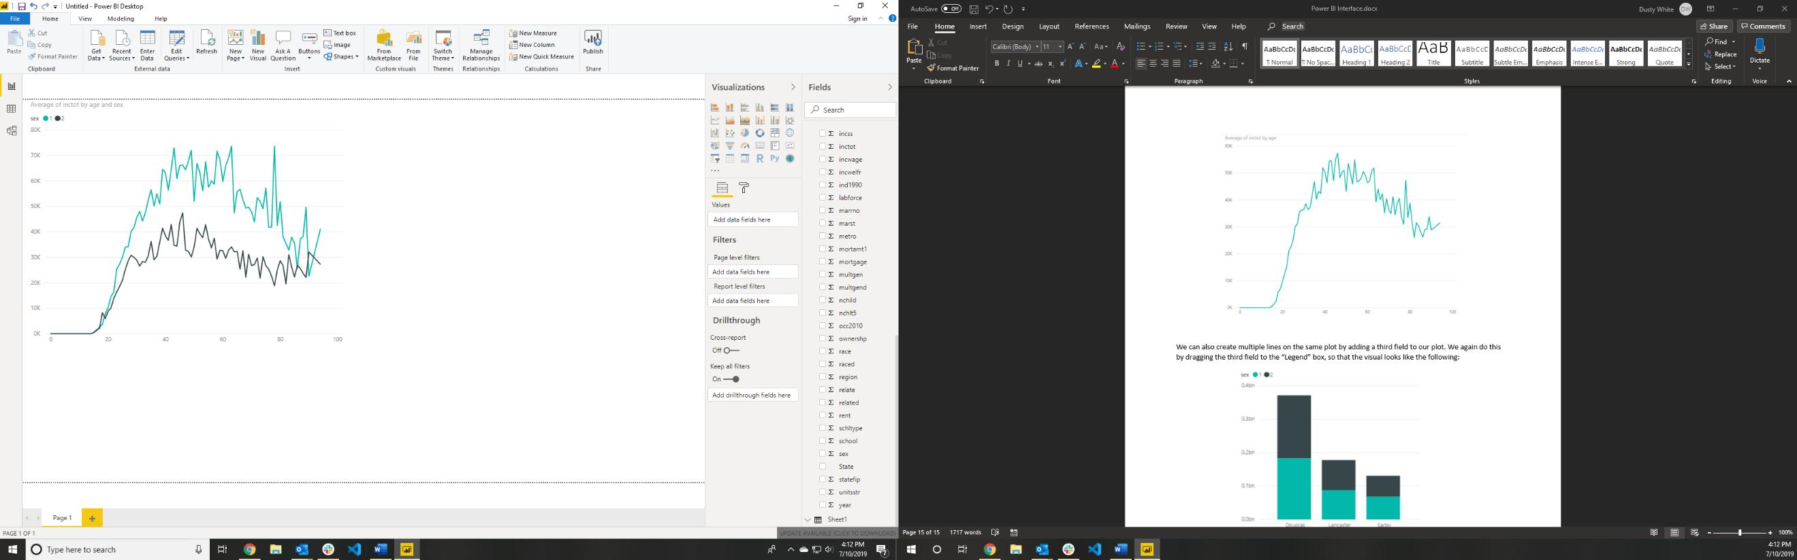We can also create multiple lines on the same plot by adding a third field to our plot. We again do this by dragging the third field to the “Legend” box, so that the visual looks like the following:

Scatter Chart

A scatter chart is normally used to present the relationship between two variables using many distinct observations or groups.



Click here

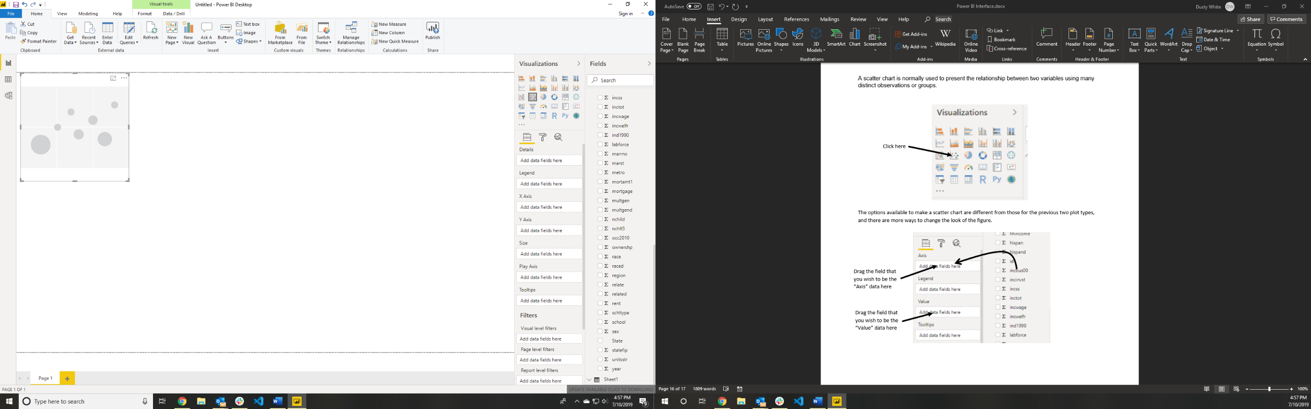The options available to make a scatter chart are different from those for the previous two plot types, and there are more ways to change the look of the figure.

Any field dragged to the legend area will create a color-coding for the plot

The field placed in the details area will create the unique groups to be plotted. If you do not use Details or Legend, your plot will only have a single point

Drag the field that will generate the x-axis here

A field placed in the size area will change the size of the points in the plot based on the value of the field (should be numeric)

Drag the field that will generate the y-axis here

Drag the field that will generate the x-axis here

Remember, when we add numeric fields to our visual to define the “Value” for categories, we can choose the type of aggregation that will be applied to the field. This is done by clicking the down arrow next to the “X” that will remove the field from the visual:

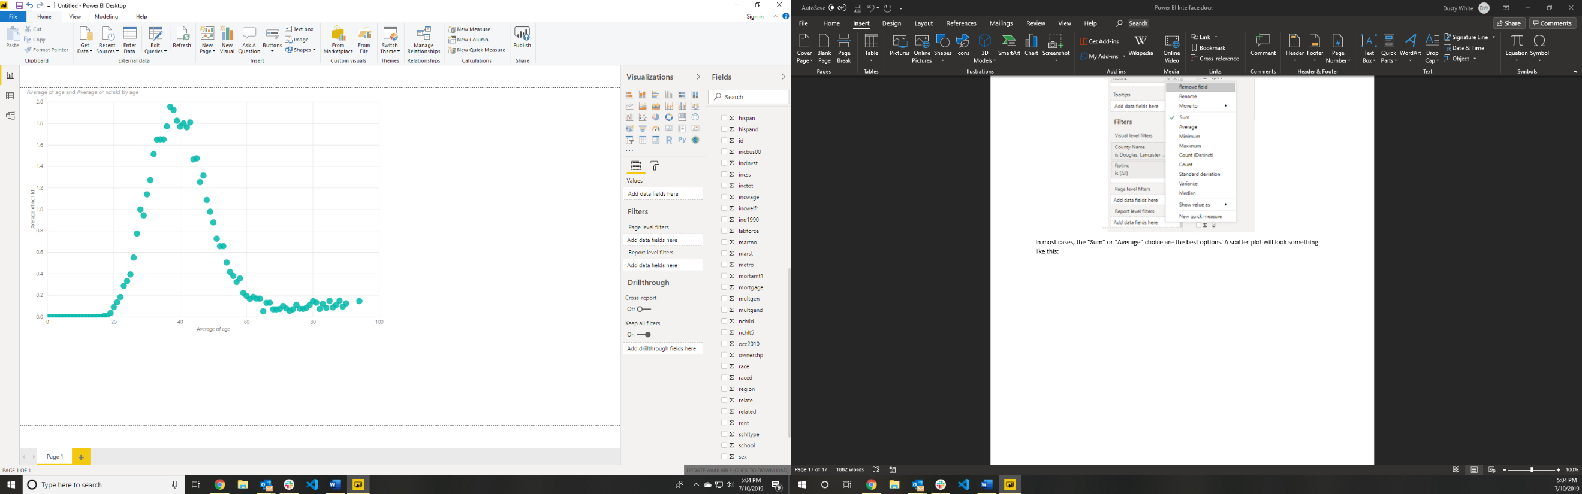In most cases, the “Sum” or “Average” choice are the best options. A scatter plot will look something like this:

Choropleth, or Filled Map

A filled map allows us to explore geographic trends, by coloring various locations based on values of the field of interest.



Click here

We will typically use the following two fields to generate our filled maps:

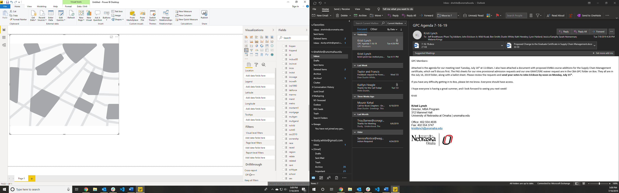

The value that we want to use to create the shading on the map (should be numeric)

The names of the locations that we want to display (state names, etc.)

Map Plot

A map plot allows us to explore geographic trends using more specific locations and additional information, by overlaying scatter points on geographic locations that can be coded using size and color to present a more robust geographic data set.



Click here

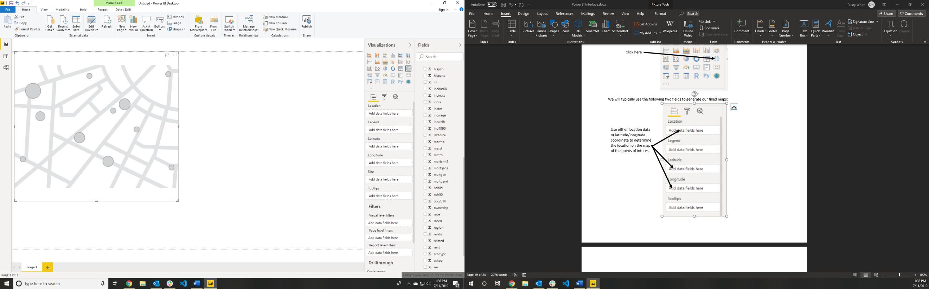We will typically use the following two fields to generate our filled maps:

Choose the color of the points

Choose a numeric measure to determine the size of the points on the map

Use either location data or latitude/longitude coordinate to determine the location on the map of the points of interest

Pie Charts

Pie charts are a common tool for representing proportions in a population. We can easily create pie charts in Power BI, and can customize them using several options available to us.



Click here

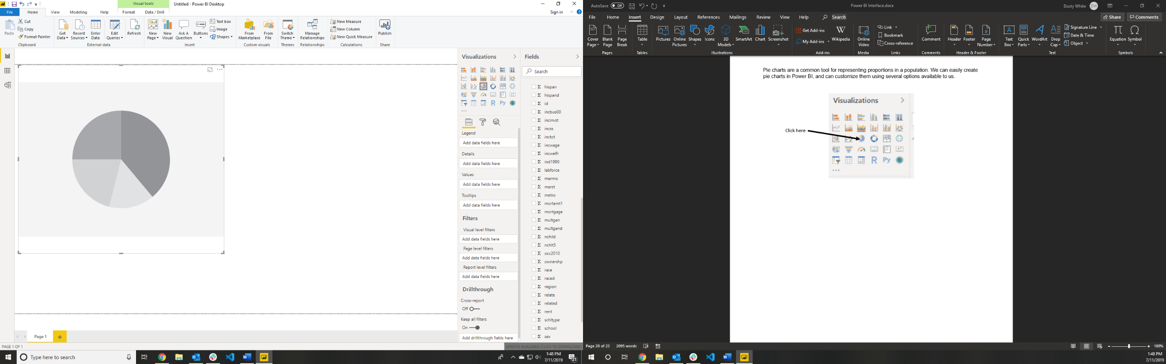

Choose groups that do not require different colors, but should be counted separately

Choose the color coding for the pie segments

Use this area to select the variable that should be reported using the shape of the pie

Power BI Table

Including tables in a Power BI report is an excellent method for presenting the raw data for selected subsets of the data set. For example, if we have processed text data, but we might want to refer to the full text once we isolate an interesting trend, we could use our visuals to choose the subset that contains the trend, and then view that subset in the table.



Click here

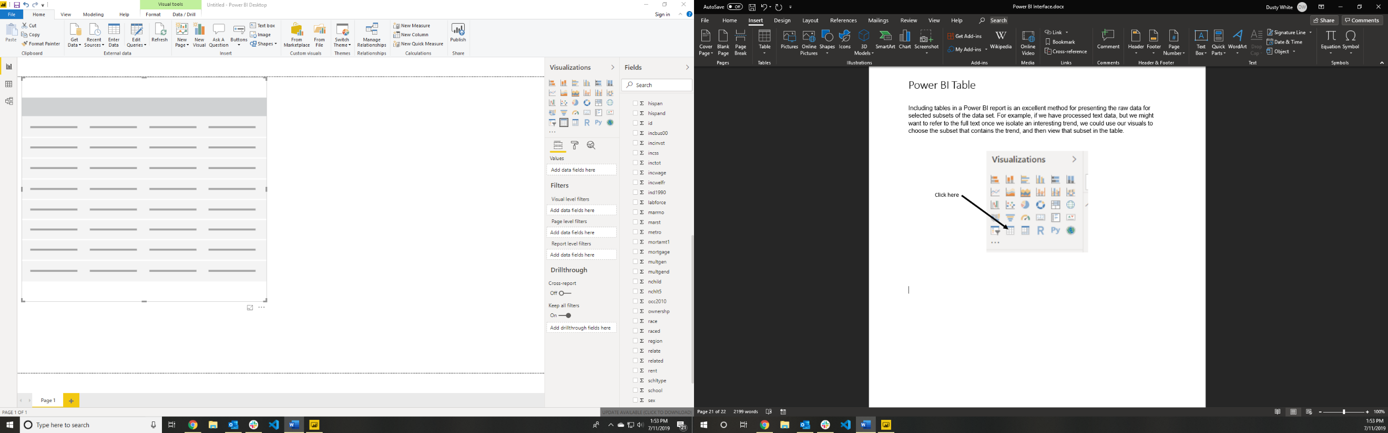

Simply add any field that should be included in the table to the Values area. You can drop as many fields as you choose

Filter Tables

Filter tables allow us to isolate subsets of our data set using simple controls displayed visibly on the report itself. These filters can be sliding scales for numeric values, dropdown menus for text options, or controls for the dates that we want to display in a line chart.



Click here

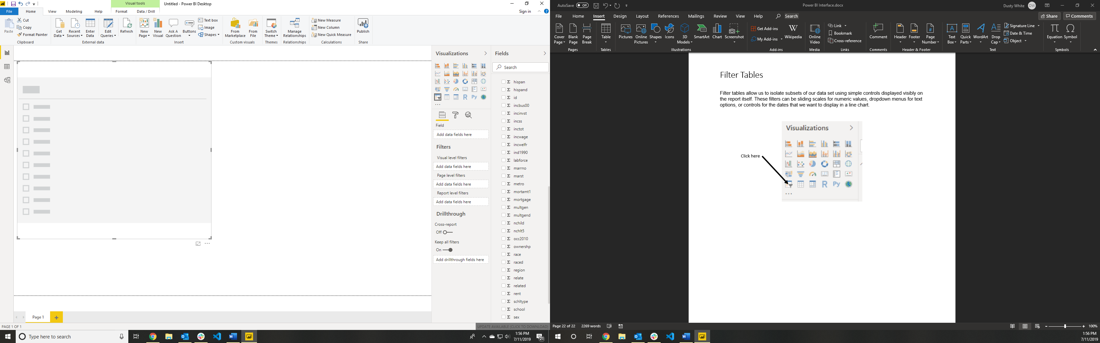

Drop the field with which you would like to filter your report into the field area. Only one field can be included in any filter, but multiple filters can be included in a report

Customizing Plots

Most plots in Power BI can be customized a great deal by using the options provided in the Visualizations column. When we create a visual, we are presented with the “Fields” tab of the Visualizations column. To customize the figure once it has been created (by changing colors, scales, or labels, for example), we need to select the “Format” tab. We will see descriptions of the most common options below.



Click here

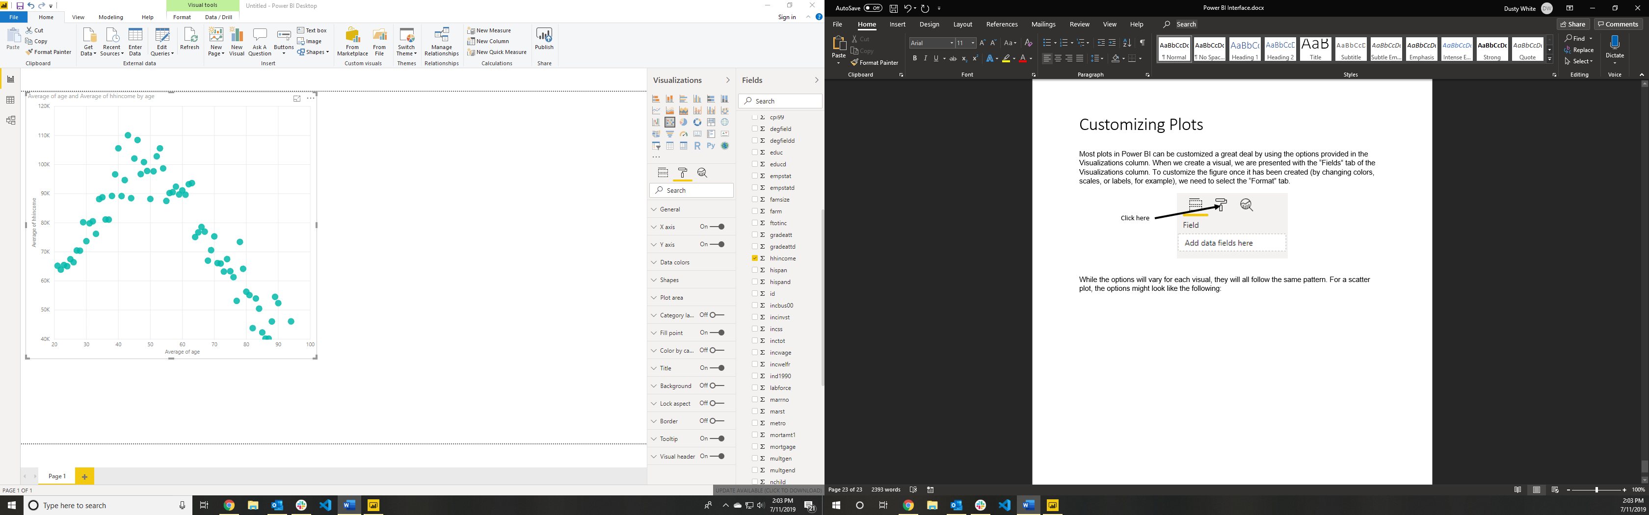While the options will vary for each visual, they will all follow the same pattern. For a scatter plot, the options might look like the following:

General Settings

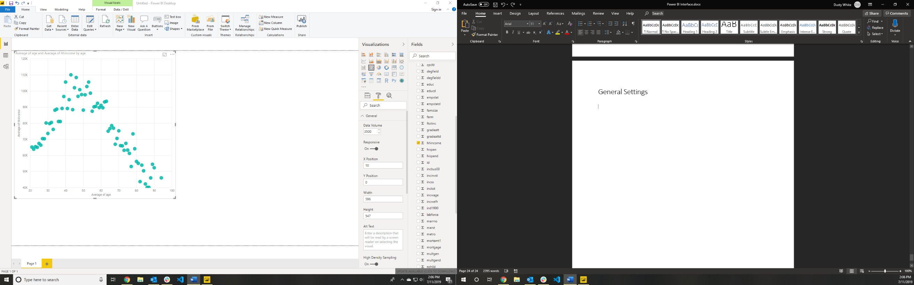

Whether or not the plot should be dynamic (interactive)

Options for detailed sizing of visuals

Options for detailed placement of visuals on the canvas using (x,y) coordinates

Maximum number of points to display on chart

Axis Settings (Apply to X or Y Axes)

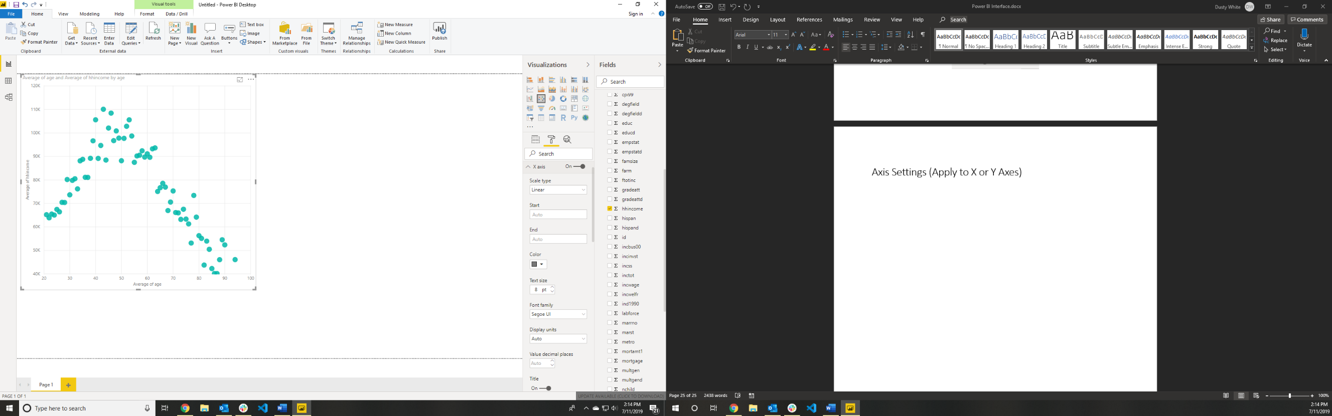

Indicate the number of decimal places to show

Choose how to display units

Select axis font size

Select axis color

Choose custom start and end points for an axis

Maximum number of points to display on chart

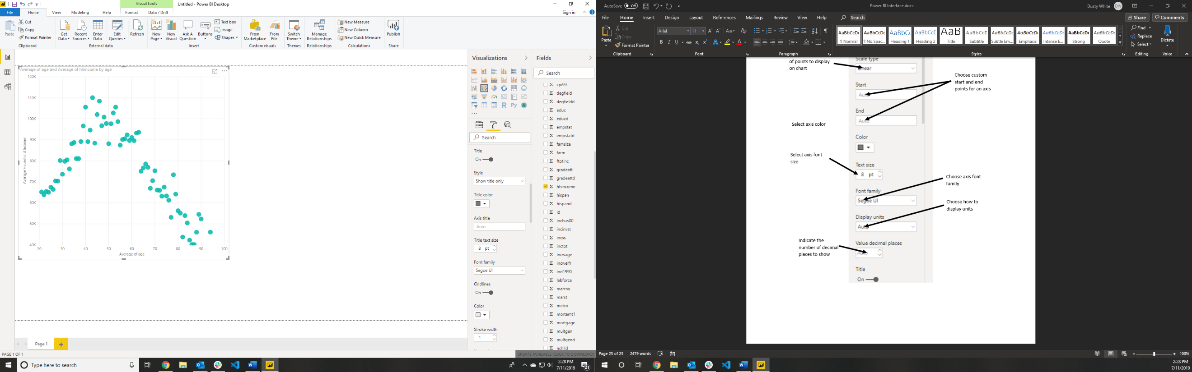

Choose the color and width of gridlines

Toggle gridlines

Choose custom font size and font family for the axis title

Create a custom title for the axis

Choose the color of the axis title

Choose the axis title style

Toggle axis title

Data Colors

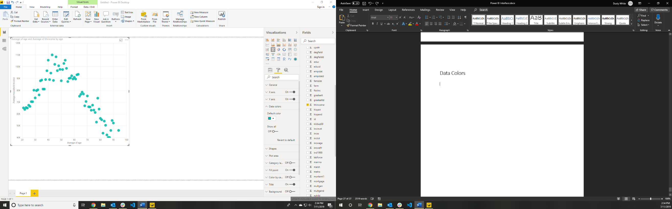

Choose the color of each group (more color groups will appear when the legend field is being used)

Shapes

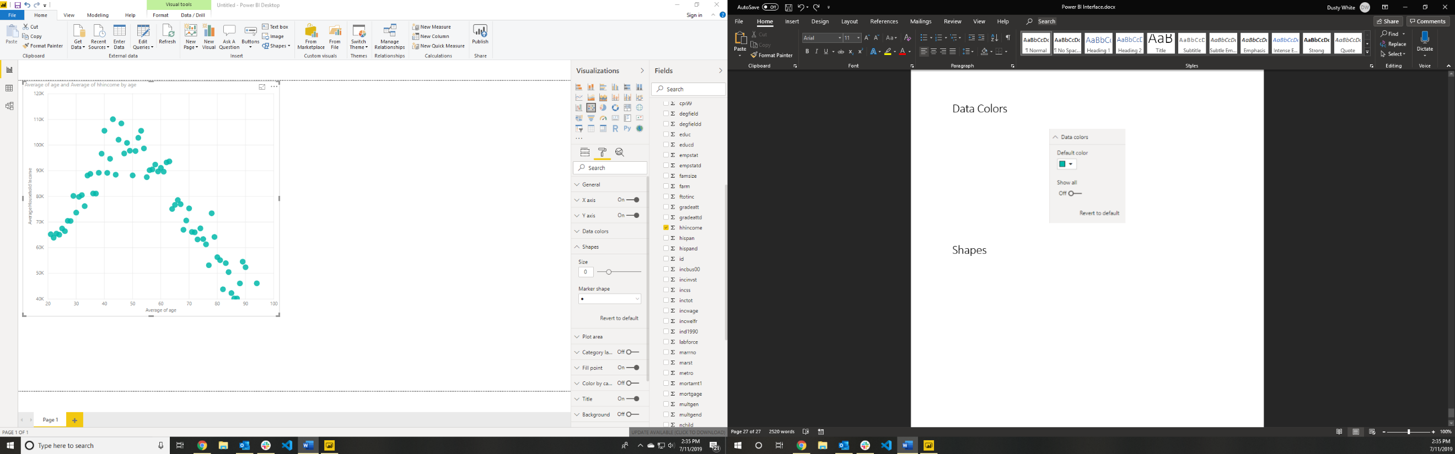

Choose the shape of markers

Choose the point size

Title

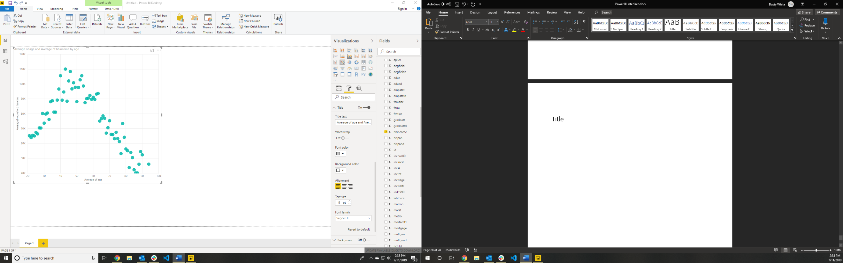

Choose title font size and font family

Select title alignment style

Choose title background color

Choose title font color

Toggle title word wrapping

Create a custom title for the figure